Second pupil tracking camera configuration: Using the light reflected from the mirror
The second configuration involves using a ELP webcam camera 1080P 30fp [1] along with a Thorlabs FEL0750 - Ø1" Long pass Filter, Cut-On Wavelength: 750 nm [2] mounted on a CP35/M - 30 mm Cage Plate [3] with a SM1L03 - SM1 Lens Tube [4]. The image acquired of the animal’s pupil is reflected from the FM02R - 25 mm x 36 mm Red Hot Mirror, AOI: 45° [5]. The mirror can be adjusted with Thorlabs Posts elements and the camera can be rotated and translated for its adequate positioning.
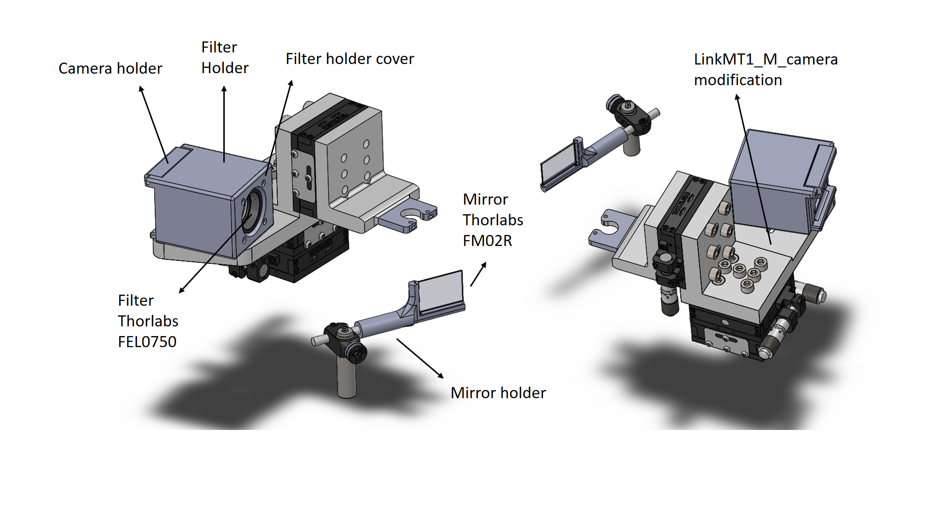
Figure 1: Second configuration description.
Bill of materials
Component | Quantity | Supplier | Reference
Mirror holder | 1 | - | 3D printed part
Camera holder | 1 | - | 3D printed part
Filter holder | 1 | - | 3D printed part
Filter holder cover | 1 | - | 3D printed part
LinkMT1_camera_modification | 1 | - | 3D printed part
M2 screw | 4 | - | -
M3 screw | 6 | - | -
M2 nuts | 4 | - | -
M6 screw | 1 | - | -
M6 nut | 1 | - | -
FEL0750 - Ø1" Long pass Filter | 1 | Thorlabs | [2]
CP35/M - 30 mm Cage Plate | 1 | Thorlabs | [3]
SM1L03 - SM1 Lens Tube | 1 | Thorlabs | [4]
FM02R - 25 mm x 36 mm Red Hot Mirror | 1 | Thorlabs | [5]
ELP webcam camera 1080P 30fp | 1 | Amazon | [1]

Assembly instructions
- Cut 2 parts of silicone tube with the same distances as the mirror sides: 36 mm and 25 mm.
- Glue both parts with the mirror holder.
- Use a scalper to meake a longitudinal cut along both blued tubes.
- Insert a 6 mm diameter Thorlabs post.
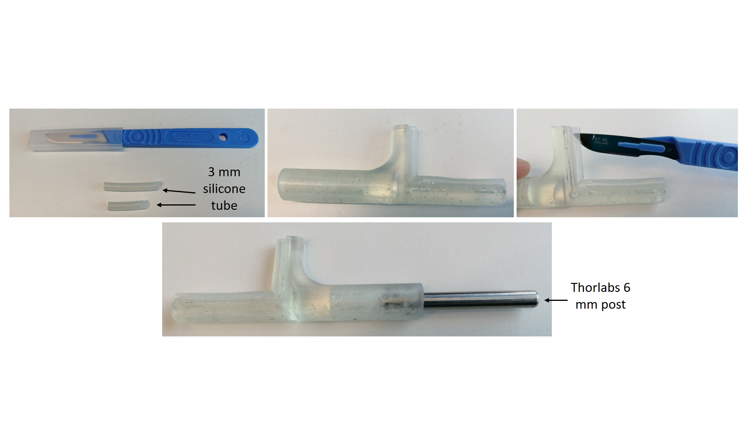
Figure 2: Mirror holder assembly.

- Use a 3D printing material with opaque features (FormLabs black resin) if the resin is clear, use black matt spray to paint it.
- Use four M2 screws and nuts to attach the camera with the camera holder part.
- Insert the Long Pass Filter, mounted on a CP35/M and a SM1L03 - SM1 Lens Tube in the filter holder and use four M3 screws to attach them with the filter holder cover.
- Use two long (25-30 mm) M3 screws as a shafts to open and close the filter holder.
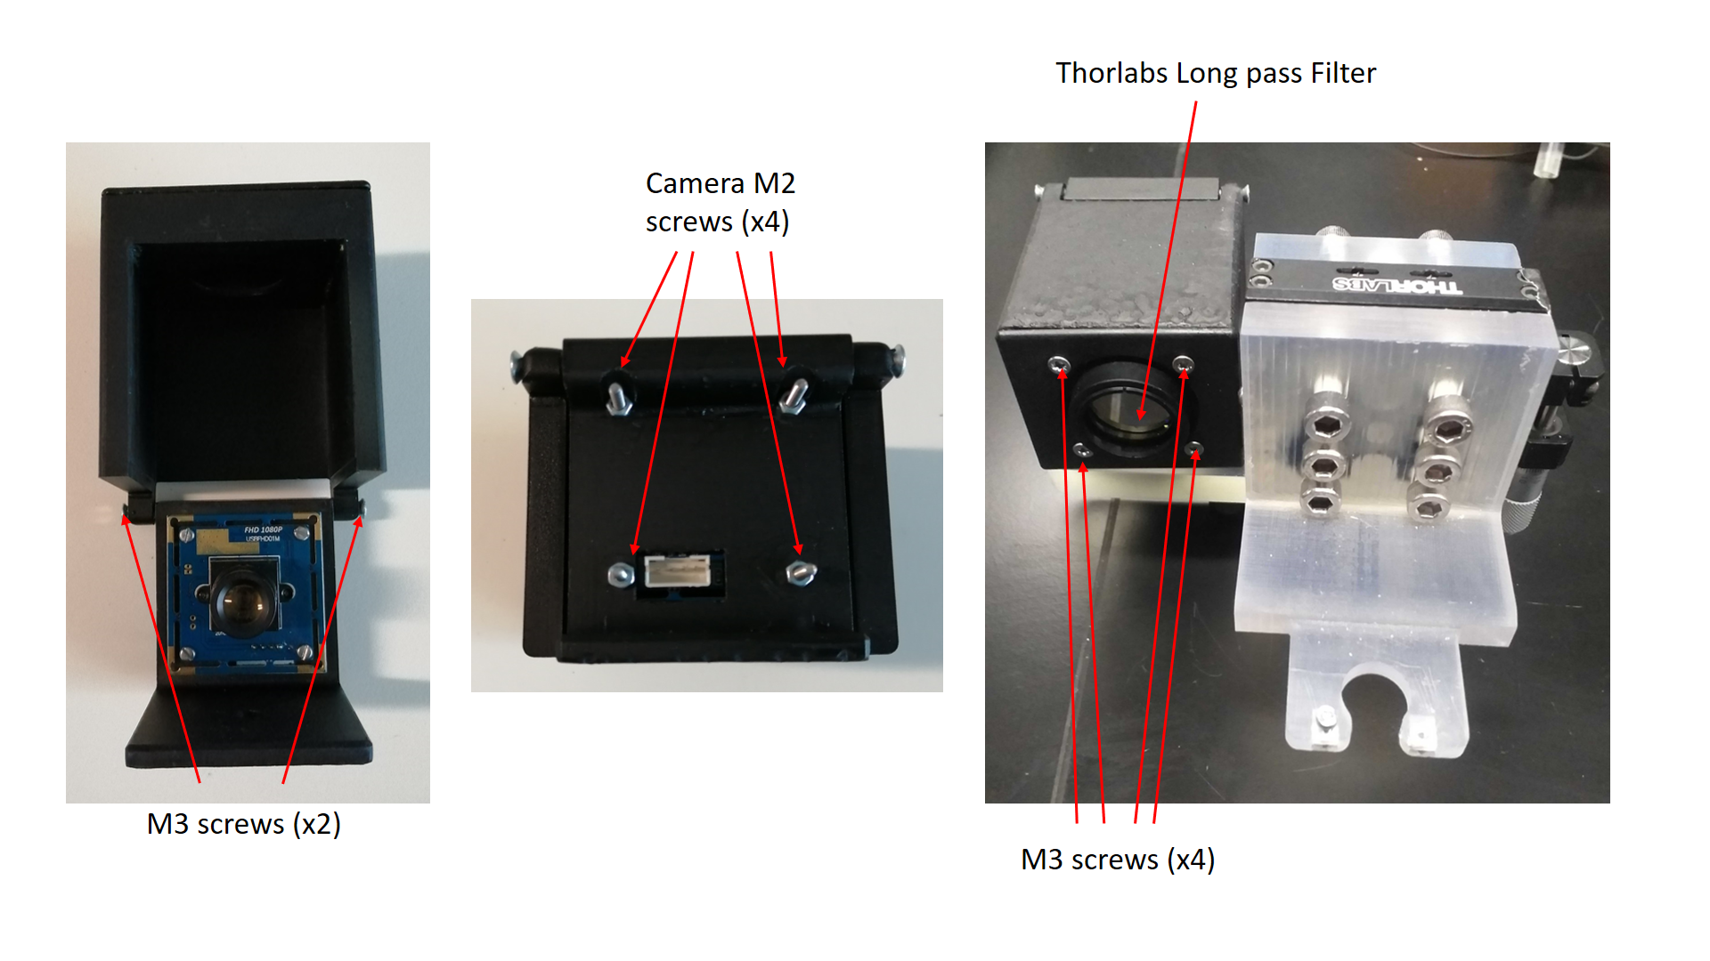
Figure 3: Camera holder assembly.

- Use a M6 screw and nut to attach the camera holder with the LinkMT1_camera_modification.
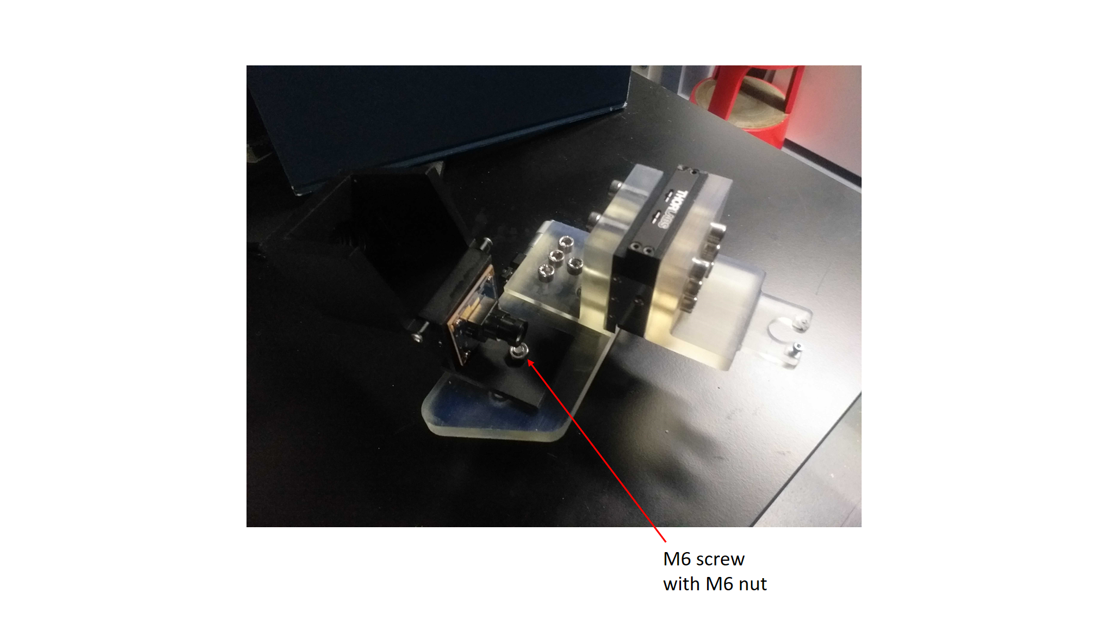
Figure 4: Head fixation system assembly.
- Attach the mirror holder on the setup using Thorlabs components (RA90TR/M [6] and 12.7 mm post [7]).
- Assembly the head fixation system with the left ring.
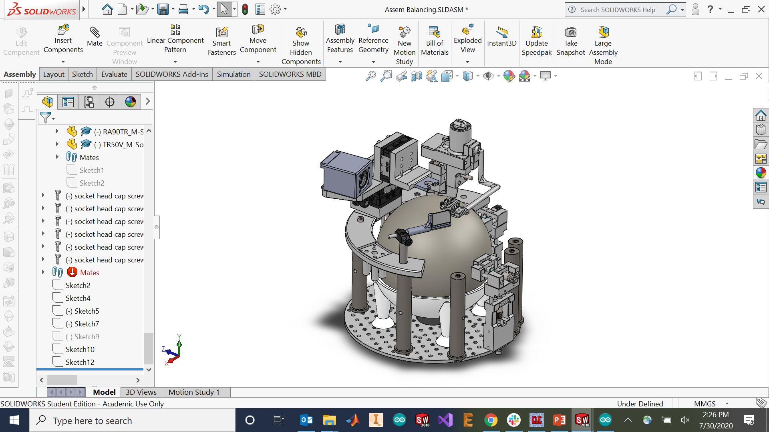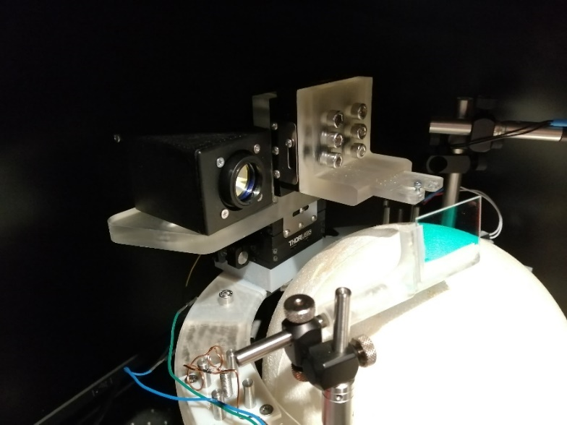
Figure 5: Modifications assembled on the virtual setup (left) and real setup (right).

References

[1] | "https://www.amazon.co.uk/gp/product/B015PCAVZG/ref=ppx_yo_dt_b_search_asin_title?ie=UTF8&psc=1," [Online].
[2] | "https://www.thorlabs.de/thorproduct.cfm?partnumber=FEL0750," [Online].
[3] | "https://www.thorlabs.com/thorproduct.cfm?partnumber=CP35/M," [Online].
[4] | "https://www.thorlabs.com/thorproduct.cfm?partnumber=SM1L03," [Online].
[5] | "https://www.thorlabs.com/thorproduct.cfm?partnumber=FM02R," [Online].
[6] | "https://www.thorlabs.com/thorproduct.cfm?partnumber=RA90TR/M," [Online].
[7] | "https://www.thorlabs.com/newgrouppage9.cfm?objectgroup_id=1266," [Online].

